**EDUCATIONAL ORGANIZATION USING SERVICENOW**

**Team Id:** NM2025TMID14805

**Team Members: 4**

**Team Leader:** **SHYAM M ( [shyammanogar33@gmail.com](mailto:shyammanogar33@gmail.com) )**

**Team Member 1: NAVEEN KUMAR V ( [kumarnaveen96573@gmail.com](mailto:kumarnaveen96573@gmail.com) )**

**Team Member 2: RAHUL S (** [**selvanrahul28@gamil.com**](mailto:selvanrahul28@gamil.com) **)**

**Team Member 3: RUEBEN CHARIS S (** [**rueben10charis@gmail.com**](mailto:rueben10charis@gmail.com) **)**

**Problem Statement:**

Educational organizations face difficulties in handling student queries, staff requests, IT support, and administrative tasks when managed manually. This leads to delays, errors, and lack of transparency. As a result, processes become inefficient and cause dissatisfaction among students and staff.

**Objective:**

1. Automate service requests and ticketing system:

Instead of writing complaints or requests manually, the system will automatically create and track tickets, making it faster and easier to manage.

2. Improve communication between students, staff, and administration:

ServiceNow provides a single platform where students, staff, and administrators can easily share information and updates, reducing miscommunication.

3. Reduce response time for IT and administrative issues:

By automating workflows, requests like login problems, Wi-Fi issues, or certificate needs can be solved quickly without unnecessary delays.

4. Provide a centralized platform for service management:

All types of requests (student, staff, IT, admin) can be managed in one place, ensuring transparency, easy tracking, and better efficiency.

**Skills:**

ServiceNow Platform, Database Management, Scripting, Problem-Solving & Analytical Skills, Documentation & Reporting, Project Management, Communication Skills, Time Management

**TASK INITIATION:**

**Milestone 1: Setting up ServiceNow Instance**

**Activity 1: Setting up ServiceNow Instance**

Step 1: Search a developer.servicenow.com

Step 2: Sign in ServiceNow.

Step 3: Click on “Request Instance”.

Step 4. Submit the request.

Step 5. Log in to your ServiceNow Instance.

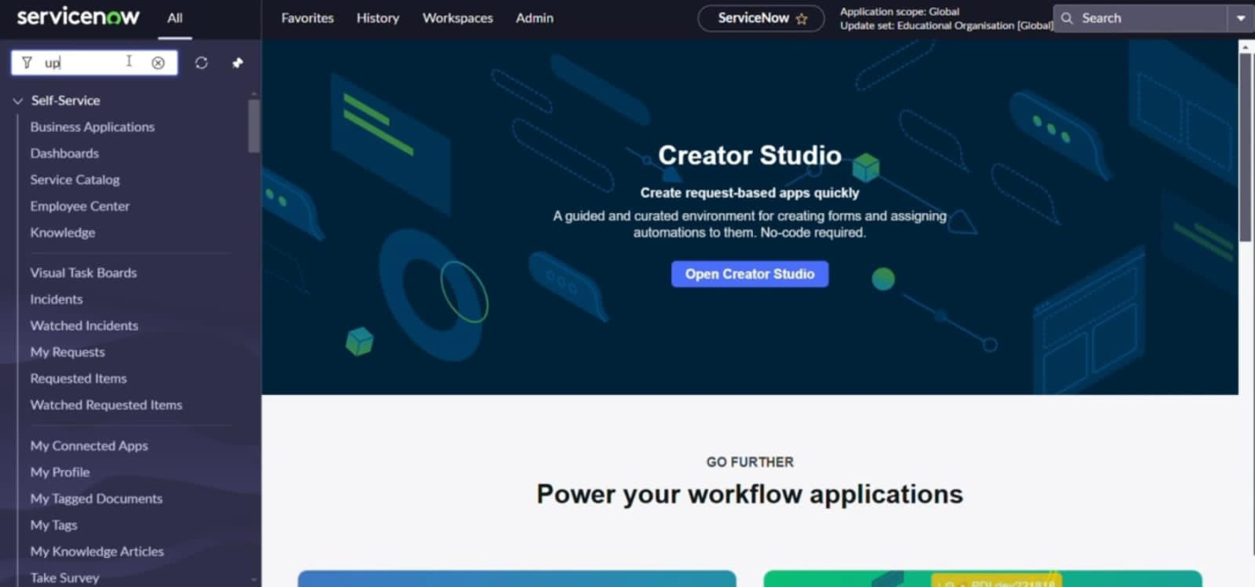

**Milestone 2: Creating a Update Set**

**Activity 1: Creating a Update Set**

Step 1. Click on All >> Local update sets.

Step 2. Click on new

Step 3. Enter the Details Name: Educational Organisation.

Step 4. Click on Submit and make Current.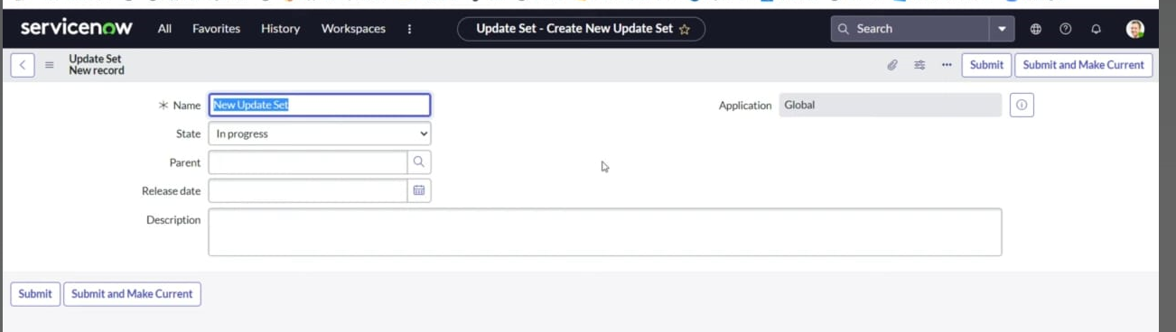

**Milestone 3: Creating a Table**

**Activity 1: Creating Salesforce Table**

Step 1. Search Tables.

Step 2. Click on New.

Step 3. Enter the label: Salesforce.

Step 4. Click on name.

Step 5. Create a column, double click the column.

Step 6. Enter the column and click the tick mark.

Step 7. Fill the Admin Name>>Save.

Step 8. Click on Controls>> Enable Extensible.

Step 9. Admin Number>>advanced view>>default value.

Step 10. Select get next padded number in Dynamic Default Value>>Update.

Step11. Click on Grade>>choices and label the value>>Update.

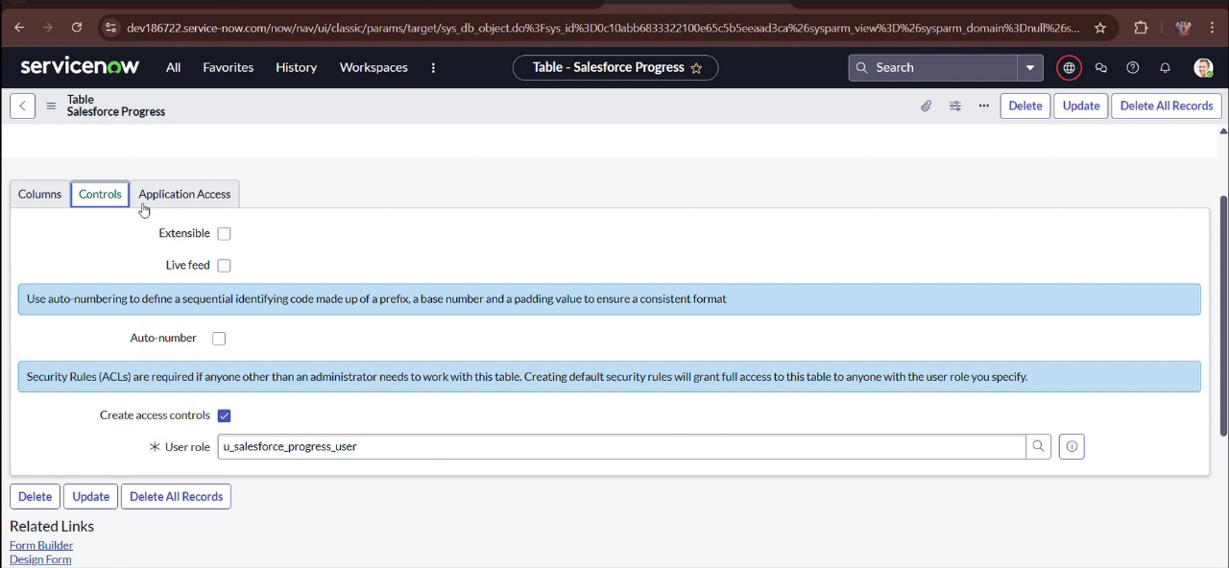

**Activity 2: Creating Admission Table**

Step 1.All>>Table>>New.

Step 2. Label: Admission>>Name>>Select extend Table.

Step 3.Salesforce, Add module to menu.

Step 4. Create fields.

Step 5. Create a Admin status.

Step 6. Create choices for Pincode.

Step 7. Create choice for Purpose of Join.

Step 8. Create choice for School.

Step 9. Create choice for School Area.

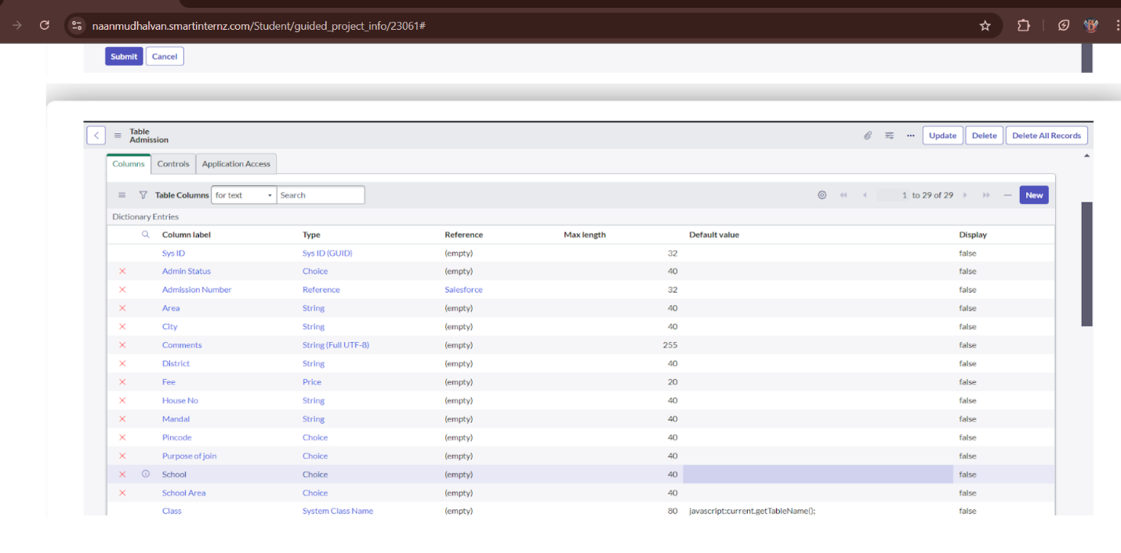

**Activity 3: Creating Student Progress Table**

Step 1. Create a Student Progress Table with Columns given.

Step 2. Select Add module to menu >>Salesforce.

**Milestone 4: Form Layout**

**Activity 1: Configuring Table form for Student Progress Table**

Step 1.In the Student Progress Table Page, Click on Layout form.

Step 2.Click on Admission Number.

Step 3. Select below Admission Number fields in Available side.

Step 4. Send it to selected side as below >> save.

**Milestone 5: Form Design**

**Activity 1:Creating Form Design for Salesforce Table**

Step 1.All >> System Definition >> Tables.

Step 2.In Label Search for Salesforce and open.

Step 3. Right Click on top Toggle >> Configure >> Form Design.

Step 4. In drop down select Salesforce(u_salesforce).

Step 5. Drag and drop the fields to the left side as below.

Step 6. Save.

**Activity 2:Creating Form Design for Admission Table**

Step 1. Follow the same steps as Activity1, Configure the fields as below and Save.

**Activity 3: Creating Form Design for Student progress Table**

Step 1. Follow the same steps as Activity1, Configure the fields as below and Save.

**Milestone 6: Number Maintenance**

**Activity 1:Creating Number Maintenance for Admin Number**

Step 1. All >> Number Maintenance >> New

Step 2. Fill the details >> Submit.

**Milestone 7: Process Flow**

**Activity 1: Creating Process Flow for Admission Table**

Step 1.All >> Process Flow>> New.

Step 2. Fill the Details as given Below.

Step 3.Right Click on toggle and click on the save.

Step 4. Replace the Name and Label as below and click on Insert on stay.

Step 5. Replace the Name and Label in order and click on Insert on stay.

Joined >> Rejected >>Rejoined>> Closed >> Cancelled.

Step 6. Order should be New >>InProgress>> Joined >> Rejected >>Rejoined>> Closed >> Cancelled.

**Milestone 8: Client Script**

**Activity 1: Creating “Auto populate” Client Scripts for Admission Table**

Step 1.All >> Client Scripts >> New.

Step 2. Fill the Details as given.

Step 3. Write the Code as below, Enable Isolate script and Save.

functiononChange(control, oldValue, newValue, isLoading, isTemplate) {

   if (isLoading || newValue === '') {

      return;

   }

   //Type appropriate comment here, and begin script below

   var a = g_form.getReference('u_admission_number');

   g_form.setValue('u_admin_date',a.u_admin_date);

   g_form.setValue('u_grade',a.u_grade);

   g_form.setValue('u_student_name',a.u_student_name);

   g_form.setValue('u_father_name',a.u_father_name);

   g_form.setValue('u_mother_name',a.u_mother_name);

   g_form.setValue('u_father_cell',a.u_father_cell);

   g_form.setValue('u_mother_cell',a.u_mother_cell);

   g_form.setDisabled('u_admin_date',a.u_admin_date);

   g_form.setDisabled('u_grade',a.u_grade);

   g_form.setDisabled('u_student_name',a.u_student_name);

   g_form.setDisabled('u_father_name',a.u_father_name);

   g_form.setDisabled('u_mother_name',a.u_mother_name);

   g_form.setDisabled('u_father_cell',a.u_father_cell);

   g_form.setDisabled('u_mother_cell',a.u_mother_cell);

}

**Activity 2: Creating “Pincode Update” Client Scripts for Admission Table**

Step 1. Fill the Details as given.

Step 2. Write the Code as below, Enable Isolate script and Save.

functiononChange(control, oldValue, newValue, isLoading, isTemplate) {

   if (isLoading || newValue === '') {

      return;

   }

    var a = g_form.getValue('u_pincode');

if(a == '509358')

{

g_form.setValue('u_mandal', 'kadthal');

g_form.setValue('u_city', 'kadthal');

g_form.setValue('u_district', 'RangaReddy');

}

else if(a == '500081')

{

g_form.setValue('u_mandal', 'karmanghat');

g_form.setValue('u_city', 'karmanghat');

g_form.setValue('u_district', 'RangaReddy');

}

else if(a == '500079')

{

g_form.setValue('u_mandal', 'Abids');

g_form.setValue('u_city', 'AsifNagar');

g_form.setValue('u_district', 'Hyderabad');

}

}

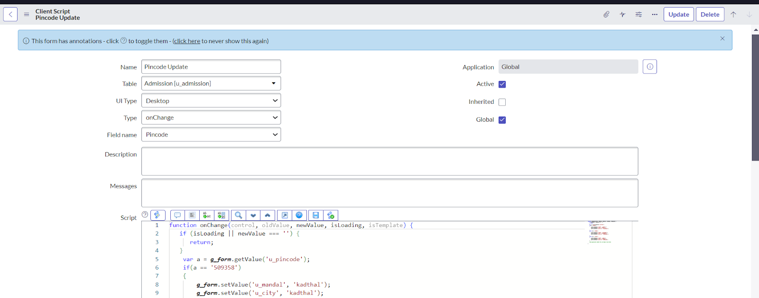

**Activity 3: Creating “Disable Fields” Client Scripts for Student progress Table**

Step 1. Fill the Details as given.

Step 2. Write the Code as below, Enable Isolate script and Save.

functiononLoad() {

   //Type appropriate comment here, and begin script below

   g_form.setDisabled('u_total',true);

   g_form.setDisabled('u_percentage',true);

   g_form.setDisabled('u_result',true);

}

**Activity 4:Creating “Total Update” Client Scripts for Student progress Table**

Step 1. Fill the Details as given.

Step 2. Write the Code as below, Enable Isolate script and Save.

functiononChange(control, oldValue, newValue, isLoading, isTemplate) {

   if (isLoading || newValue === '') {

      return;

   }

   //Type appropriate comment here, and begin script below

if (newValue){

var a = parseInt(g_form.getValue('u_telugu'));

var b = parseInt(g_form.getValue('u_hindi'));

var c = parseInt(g_form.getValue('u_english'));

var d = parseInt(g_form.getValue('u_maths'));

var e = parseInt(g_form.getValue('u_science'));

var f = parseInt(g_form.getValue('u_social'));

var Total = parseInt(a+b+c+d+e+f);

g_form.setValue('u_total', Total);

}

}

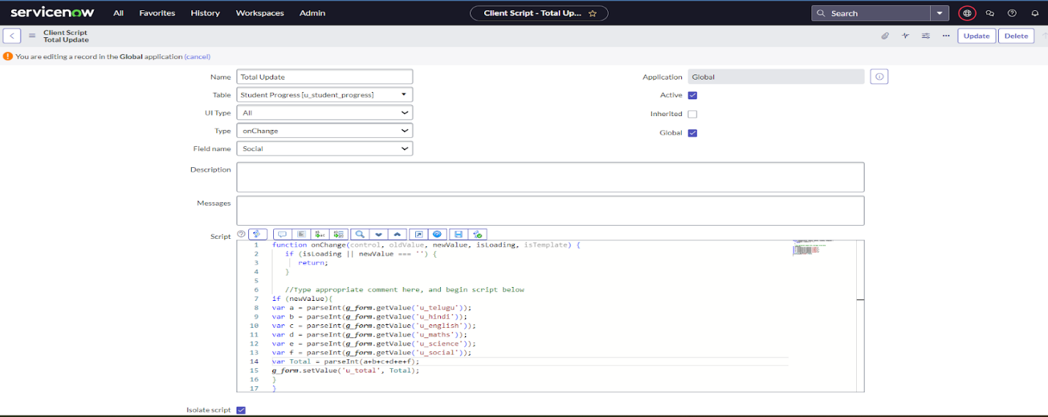

**Activity 5: Creating “Result” Client Scripts for Student progress Table**

Step 1. Fill the Details as given.

Step 2. Write the Code as below, Enable Isolate script and Save.

functiononChange(control, oldValue, newValue, isLoading, isTemplate) {

   if (isLoading || newValue === '') {

      return;

   }

   //Type appropriate comment here, and begin script below

   if(newValue) {

      var a = parseInt(g_form.getValue('u_percentage')); // Convert the value to an integer for comparison

      if(a >= 0 && a <= 59){

         g_form.setValue('u_result','Fail');

      } else if(a >= 60 && a <= 100) {

         g_form.setValue('u_result','Pass');

      } else {

         // Handle the case if a is out of range (optional)

         g_form.addErrorMessage('Percentage should be between 0 and 100.');

         g_form.clearValue('u_result');

      }

   }

}

**Activity 6: Creating “Percentage” Client Scripts for Student progress Table**

Step 1. Fill the Details as given.

Step 2. Write the Code as below, Enable Isolate script and Save.

functiononChange(control, oldValue, newValue, isLoading, isTemplate) {

   if (isLoading || newValue === '') {

      return;

   }

   //Type appropriate comment here, and begin script below

   var Total = g_form.getValue('u_total');

   var Percentage = (Total/600)*100;

   g_form.setValue('u_percentage',Percentage+'%');

}

**Conclusion:**

The implementation of ServiceNow in educational institutions helps automate tasks, streamline workflows, and improve communication between students, staff, and administrators. It reduces response times, enhances transparency, and supports better decision-making, leading to a more efficient and effective academic environment.